# Home

UX Design

Version 1.0

Developed by Nguyen Thanh Tam

History

|  |  |  |  |  |  |
| --- | --- | --- | --- | --- | --- |
| **Date** | Ver. | Description | Page | Written By | Mentor |
| 2022.04.29 | 1.0 | UX Design Document | All | TamNT | ThanhPB |

Table of content

1. Screen Spec 4

|  |  |  |
| --- | --- | --- |
| 1.1. | Home Layout ....................................................................................................................................................................................................................................… | 5 |
| 1.2. | Status Bar ........................................................................................................................................................................................................................................... | 6 |
| 1.3. | Application Screen ............................................................................................................................................................................................................................. | 7 |
| 1.4. | Widget Area ........................................................................................................................................................................................................................................ | 8 |
| 1.5.  2. Flow Spec | List App ......................................................................................................................................................................................................................................……. | 9  **11** |
| 2.1. | Open and Close App ......................................................................................................................................................................................................................… | 12 |
| 2.2. | Scroll app list .................................................................................................................................................................................................................................… | 13 |
| 2.3. | Reorder app ...................................................................................................................................................................................................................................…. | 14 |
| 2.4. | Climate Application to Widget..........................................................................................................................................……………………………………………………………. | 15 |
| 2.5. | Map Application to Map widget…………………………………………………………………………………………………………………………………………………………………………………………….. | 16 |
| 2.6. | Media Application to Media widget……………………………………………………………………………………………………………………………………………………………………………………….. | 17 |

# Screen Spec.

* 1. Home Layout

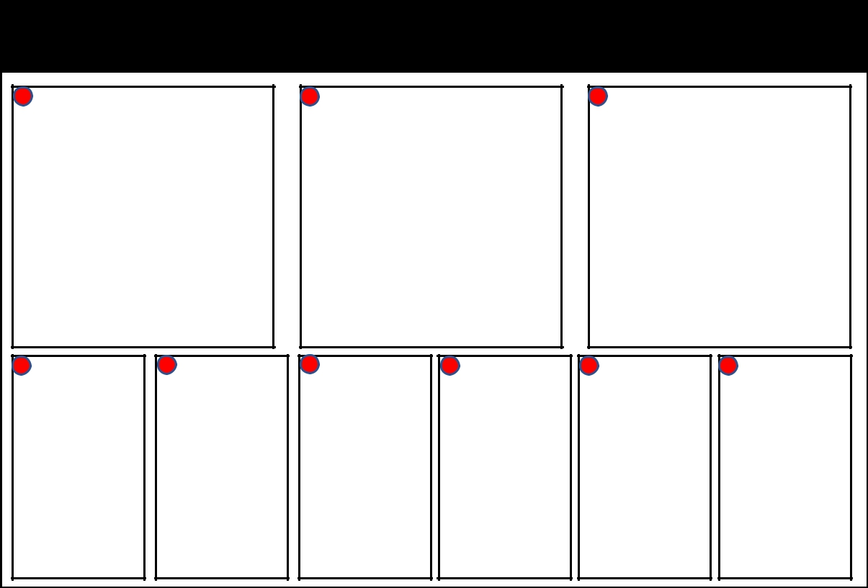

| 00:00 | Mar. 14 |

3

2

1

|  |  |  |
| --- | --- | --- |
| Navigation | Climate | Media |
| Widget | Widget | Widget |

4

4

4

4

4

4

|  |  |  |  |  |  |  |
| --- | --- | --- | --- | --- | --- | --- |
|  | | | 4 |  | | |
| App | App | App |  | App | App | App |
| Icon | Icon | Icon |  | Icon | Icon | Icon |

|  |  |  |  |  |
| --- | --- | --- | --- | --- |
| **No.**  1 | **Description** | **Type** | **Display/Action condition**  Always/Click | **Label** |
| Navigation Widget: Go to navigation screen | Button |  |
| 2 | Climate Widget: Go to climate screen | Button | Always/Click | Climate |
| 3 | Media Widget: Go to Media Player screen | Button | Always/Click | USB Music |
| 4 | Applications (Map, Video, Media, Phone, Radio, Settings)  (Only 6 apps can be displayed at a time) | Button | Always/Click | Map, Video, Media, Phone, Radio, Setting |

* 1. Status Bar

3

2

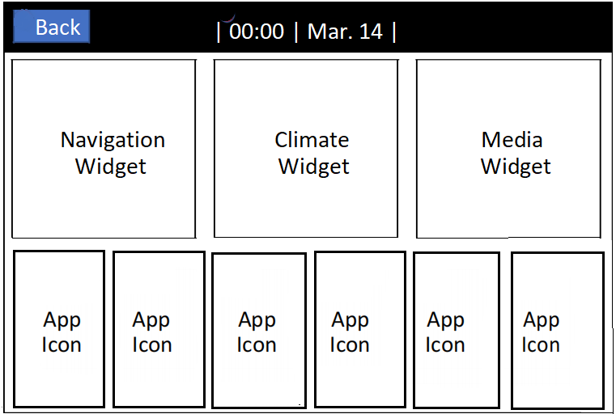

1

|  |  |  |  |  |
| --- | --- | --- | --- | --- |
| **No.** | **Description** | **Type** | **Display Condition/Action Condition** | **Label** |
| 1 | Back Button | Button | When not on Main Screen |  |
| 2 | Time: Current time | Text | Always | Format 24h ( ) |
| 3 | Date: Current date | Text | Always | Format: <Short Month>. Day |

* 1. Application Screen

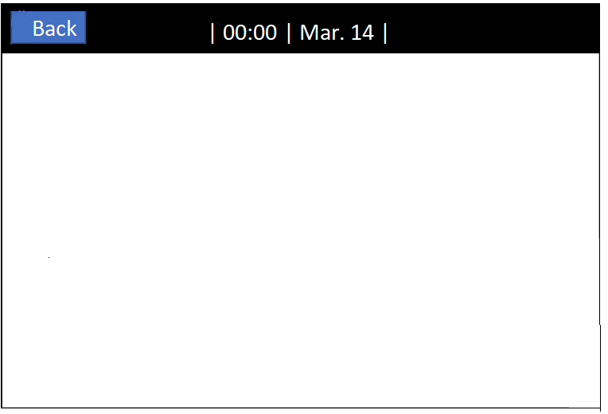

1

2

Application Area

|  |  |  |  |  |
| --- | --- | --- | --- | --- |
| **No.** | **Description** | **Type** | **Display Condition/Action Condition** | **Label** |
| 1 | Back: Back to Home screen | Button | Display it when enter other screen such as (Navigation, Climate, Media, …) | - |
| 2 | Application Area | Application | Display it when open a application from Home screen | - |
|  |  |  |  |  |

* 1. Widget Area



1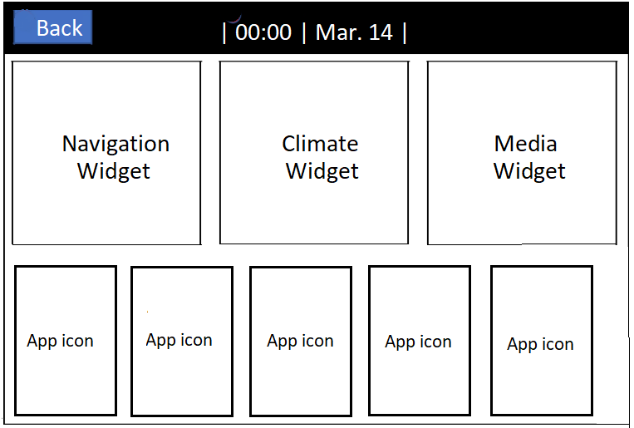

3

2

|  |  |  |  |  |
| --- | --- | --- | --- | --- |
| **No.** | **Description** | **Type** | **Display Condition/Action Condition** | **Label** |
| **1** | Navigation Widget: Display information about a Map application | Button | Always/Click |  |
| **2** | Climate Widget: Display information about a Climate application | Button | Always/Click |  |
| **3** | Media Widget: Display information about a Media application | Button | Always/Click |  |

* 1. List App



1

1

1

1

1

1

|  |  |  |  |  |
| --- | --- | --- | --- | --- |
| **No.** | **Description** | **Type** | **Display Condition/Action Condition** | **Label** |
|  | List App can only show 6 app at a time.  If there are more than 6, List App is scrollable |  |  |  |
|  | Only Focus 1 App at the time |  |  |  |
| **1** | Application (Map, Video, Media,…) | Button | Always/Click | Map |

* 1. Flow Spec.
  2. Open and Close App

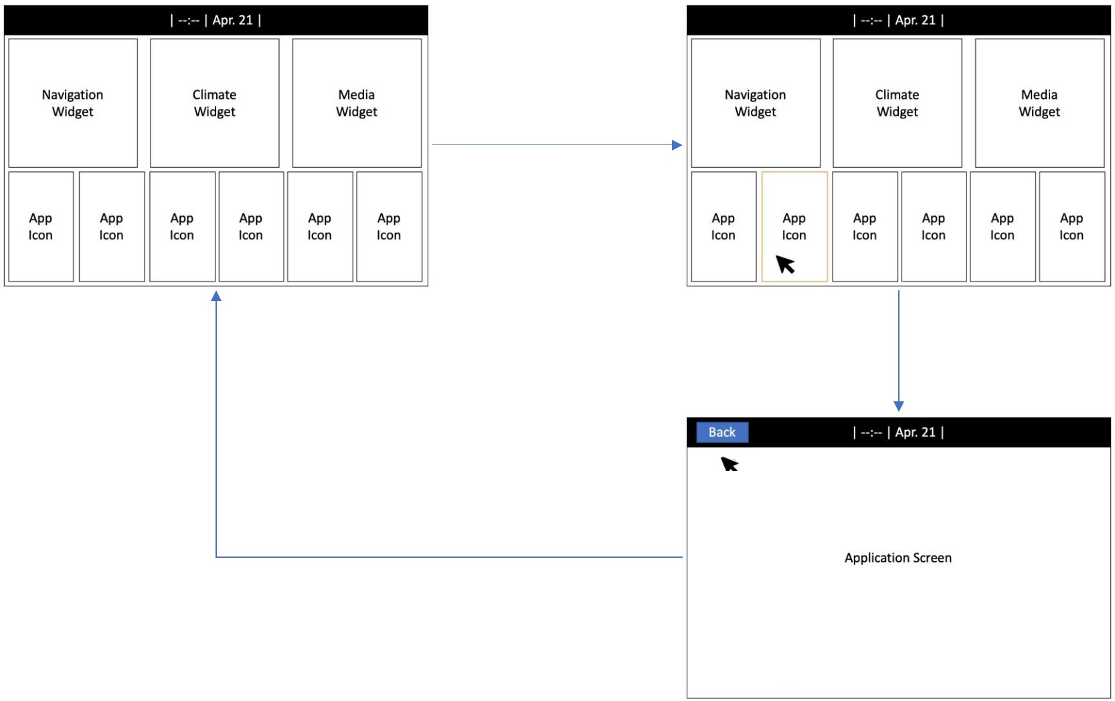

Clicked to app

or widget

Show application screen

and back button

Clicked back button

* 1. Scroll app list

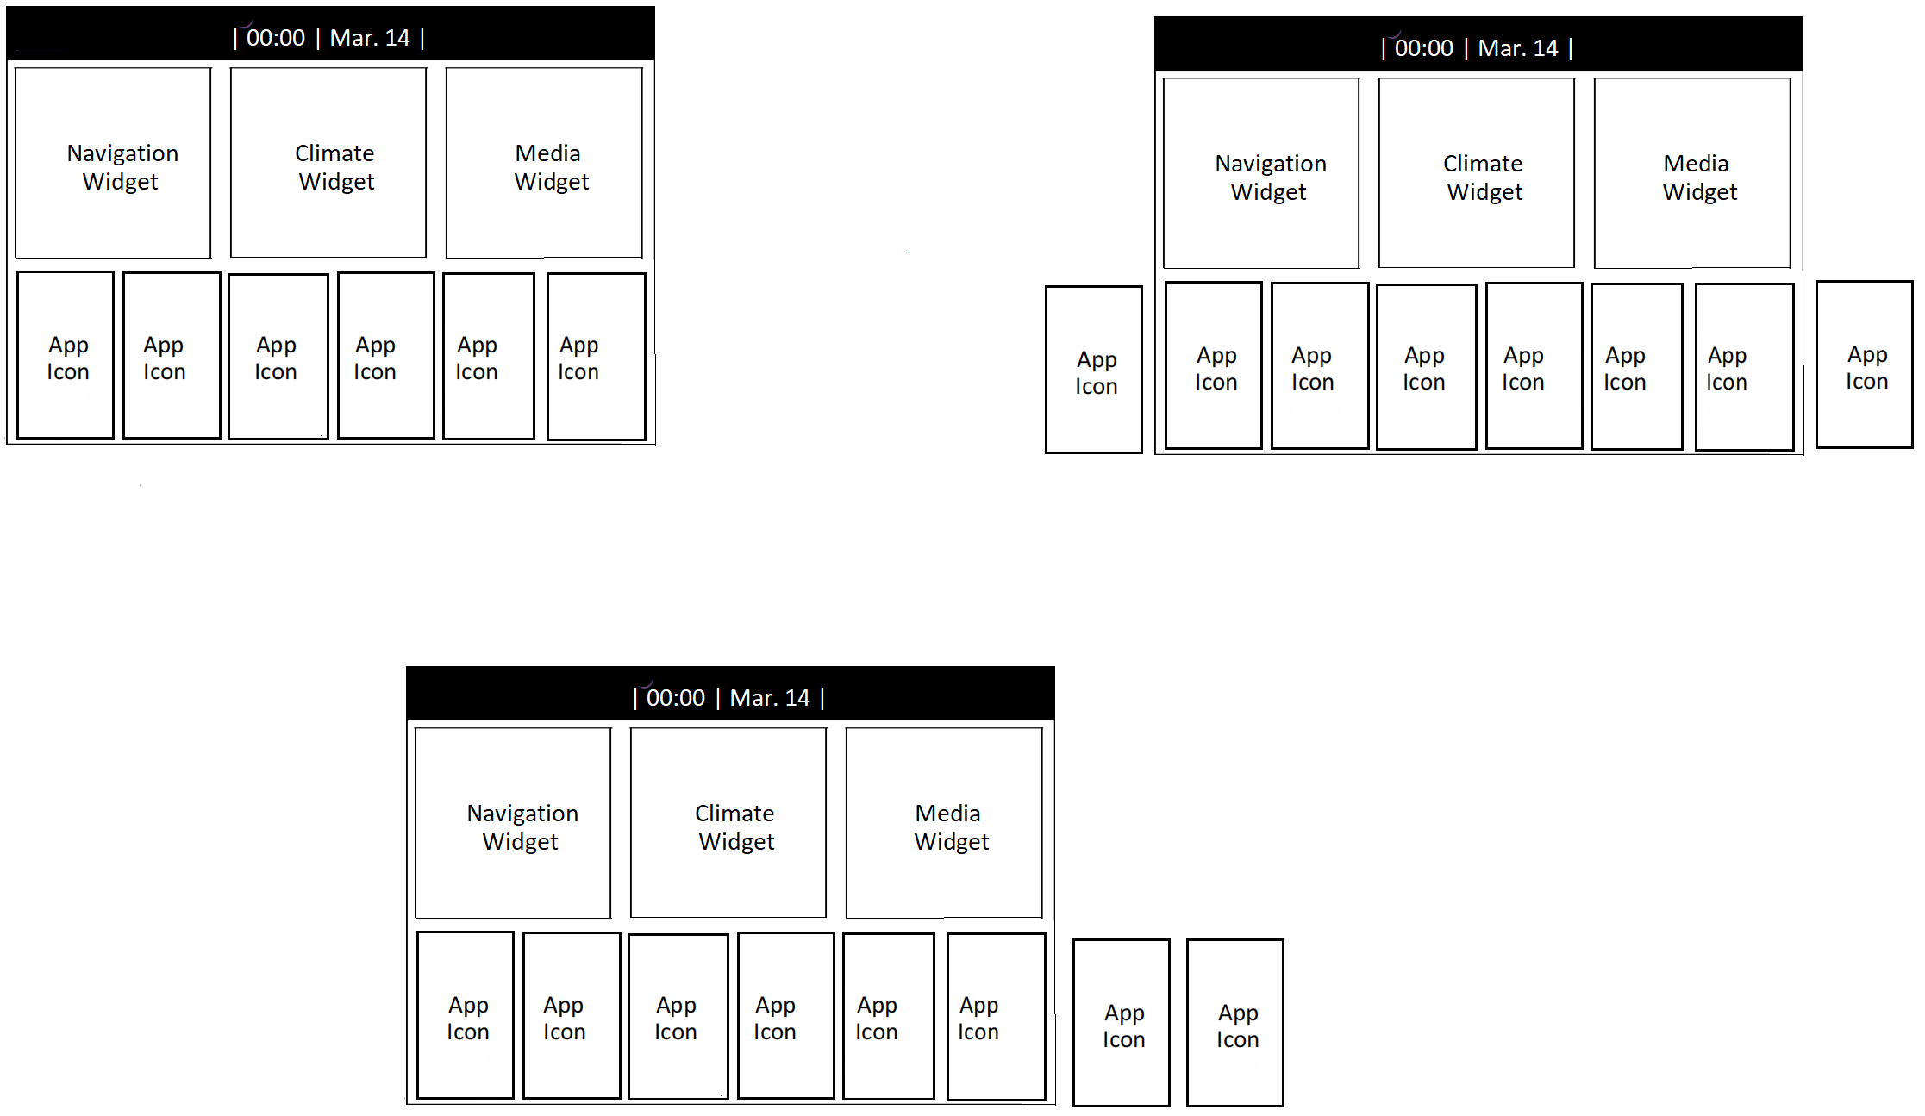

Scroll right

Scroll left

* 1. Reorder app

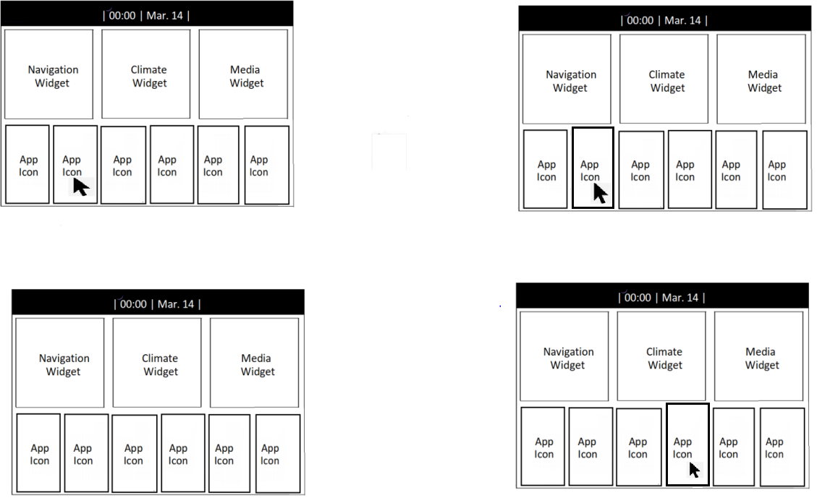

Release to exit “Drag”

state

Reorder app

Press and hold to enter “Drag” state

1

3

4

2

5

6

6

5

2

4

3

1

61

5

4

3

2

1

2

6

5

4

3

1

* 1. Climate Application to Climate widget

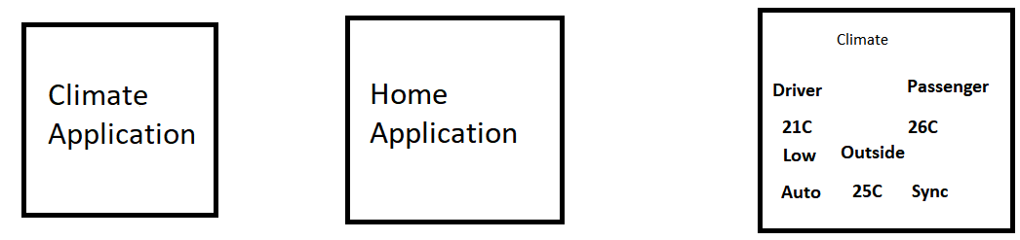

2

1

Send Information

6

4

5

3

Request information and response

|  |  |  |  |  |
| --- | --- | --- | --- | --- |
| **No.** | **Description** | **Type** | **Display Condition/Action Condition** | **Label** |
|  | Climate widget show information base on Simulator App |  |  |  |
| **1** | Driver Temperature | Text | Always |  |
| **2** | Low/High indicator | Text | Low when (1) is equal to 16.5oC  High when(1) equal to 31.5oC |  |
| **3** | AUTO mode | Text | Always |  |
| **4** | Outside temperature | Text | Always |  |
| **5** | SYNC mode | Text | Always |  |
| **6** | Passenger temperature | Text | Always |  |

2.6. Map Application to Map widget

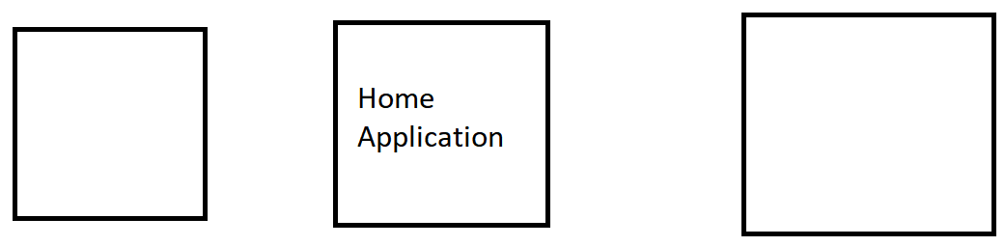

Request information and response

Send Information

Map Widget

Map Application

2.7. Media Application to Media widget



Request information and response

Send Information

Media Application

Media Widget